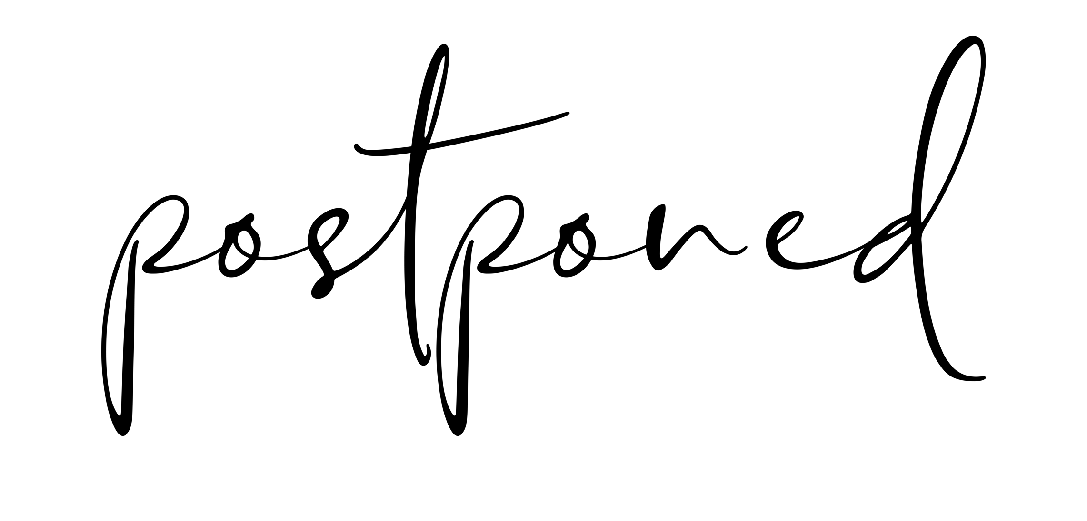­

WE REGRET TO INFORM YOU THAT   
DUE TO THIS UNCERTAIN TIME  
THE WEDDING OF

JAMES   
&  
KATIE

WILL NOT TAKE PLACE AS SCHEDULED

WE WILL SHARE THE NEW DATE   
WITH YOU AS SOON AS POSSIBLE